Letter of Agreement – Hazard Pay
Regarding hazard pay during the coronavirus public health crisis
Agreement By and Between Oregon Supported Living Program (the “Employer”) and Service Employees International Union Local 503 (the “Union”)

Effective April 5, 2020, the Employer and the Union hereby agree to implement a one dollar ($1.00) per hour hazard pay differential for all DSPs for all hours worked during the term of this Letter of Agreement. Paid Leave shall not qualify for this hazard pay. This Letter of Agreement shall expire on June 27, 2020, or on a date mutually agreed to by the parties.

For the Union: For the Employer:
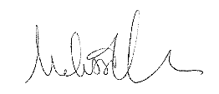 3/31/20 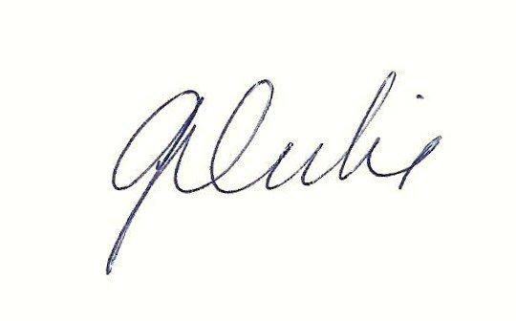3/30/2020
_____________________________ ________________________________
Melissa Unger Date Gretchen Dubie Date

